housing things

<https://livingpad.co.uk/number-8-staffs-uni-6-bedroom-house>  
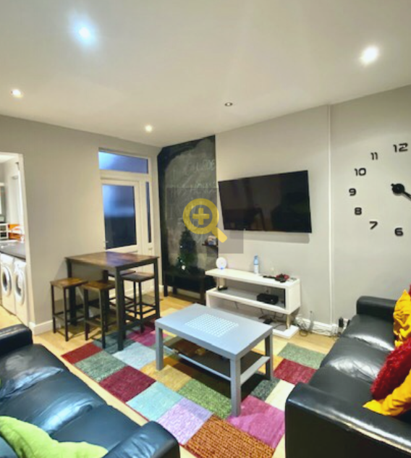  
summary:

* 6 bed
* £94 pp/pw
* 8 Watford street (0.2 miles)  
  pros:
* two ovens + washing machine + dryer
* dishwasher
* garden (barbecues?)
* has a bath
* very nice bathrooms
* nice rooms with mirrors on wardrobe
* double beds, desks, etc
* chalk board  
  cons:
* only 2 bathrooms
* slightly further
* ugly rug

<https://student-cribs.com/locations/stoke-on-trent/17-ashford-street/>  
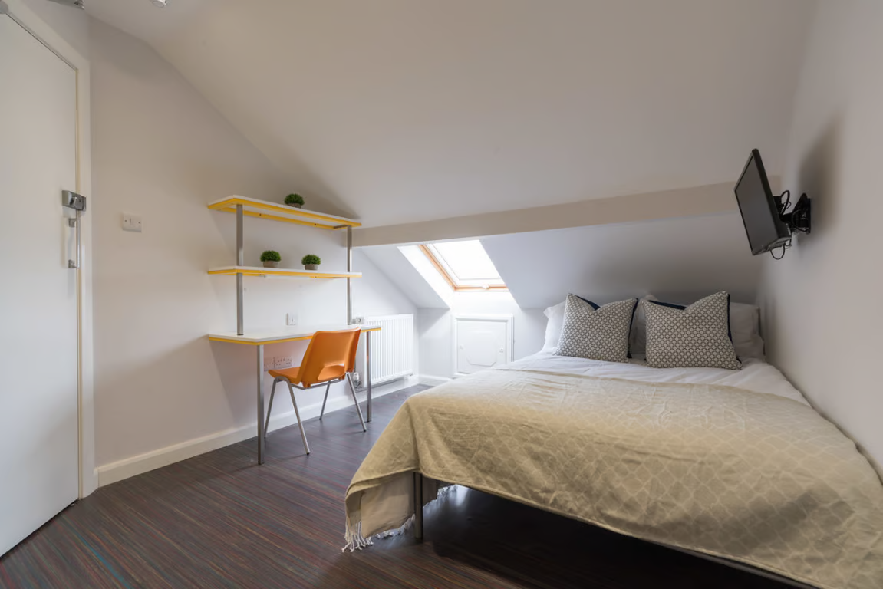  
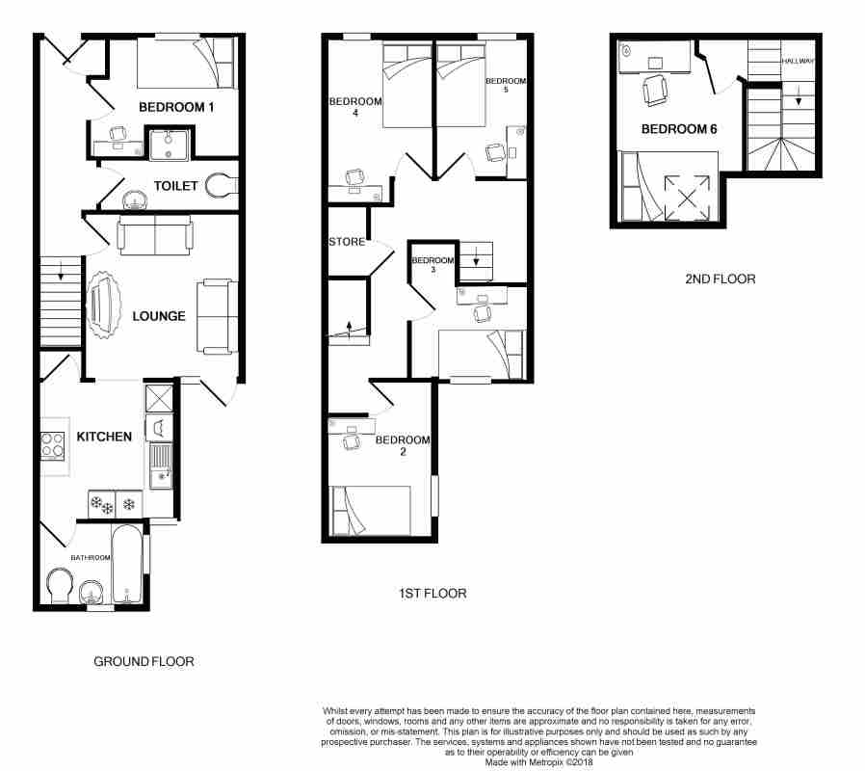  
summary:

* 6 bed
* 17 Ashford Street
* £85 pp/pw
* same distance basically  
  pros:
* has bath and shower (separate)
* really nice rooms, double beds
* have desks etc and lots of space
* has washing machine
* each room has a tv, if you care about that
* kitchen looks super modern
* gas hob
* doors that lock  
  cons:
* only 2 bathrooms
* doesnt seem to have dishwasher :(
* funny bathroom opposite kitchen

<https://www.unihomes.co.uk/property/244045087/stoke-on-trent/shelton/6-bedroom-student-house/boughey-road>  
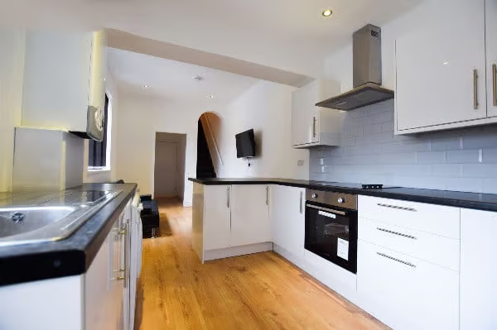  
summary:

* 66 Boughey Road
* £90 pp/pw
* again same distance
* 6 bed
* really good landlord, great reviews  
  pros:
* available from 1st July
* nice rooms, kitchen
* has three bathrooms  
  cons:
* bathroom doesnt seem to have a mirror
* hard floors in bedroom

<https://www.rightmove.co.uk/properties/131690192#/?channel=STU_LET>  
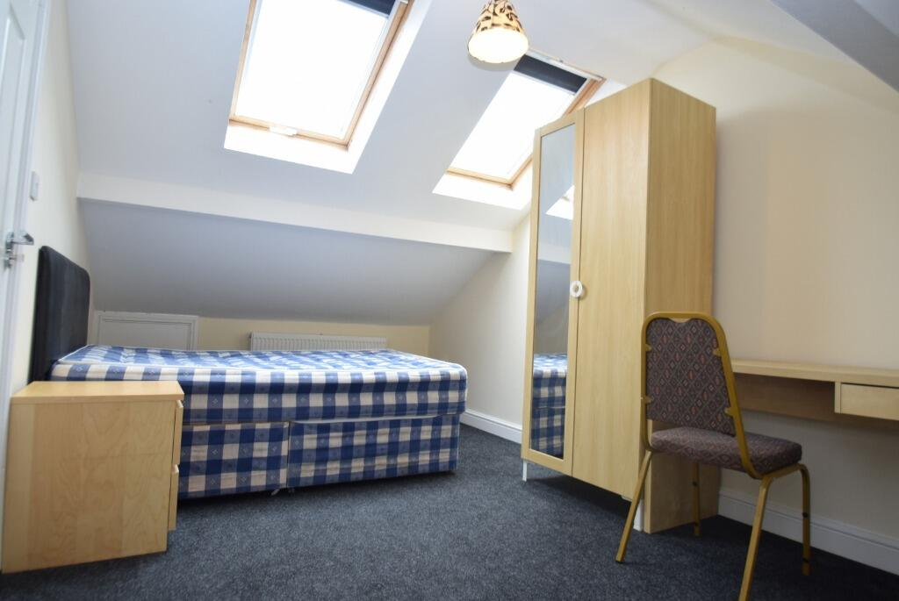  
summary:

* £90 or £95 pp/pw  
  pros:
* big rooms
* decent kitchen
* 2 bathrooms + toilet
* washing machine  
  cons:
* minimum 52 weeks tenancy
* doesnt have the best vibes